 |  |  | Standard Work Sheet
Process: Upload a Document to a Performance Review |  |  | Purpose: How to print and save a copy of a review.
Total Cycle Time: |  |  | Takt Time:
Work in Progress: n/a |  |  | Document Owner: Talent Development
When does this process occur: For Face to face meeting
Revision # |  |  | Date Updated: 6/1/2020
Step | Description: | Key Point / Image / Reason |  | Who | Cycle Time
1 | Option 1.  Navigate directly to your Performance Review Summary page by clicking the link provided.  You will need to toggle between reviews assigned to you, or your own review as necessary.  Select/deselect required status to find the desired review.  Click the desired review once identified. | Click here to navigate to your Performance Review Summary Page  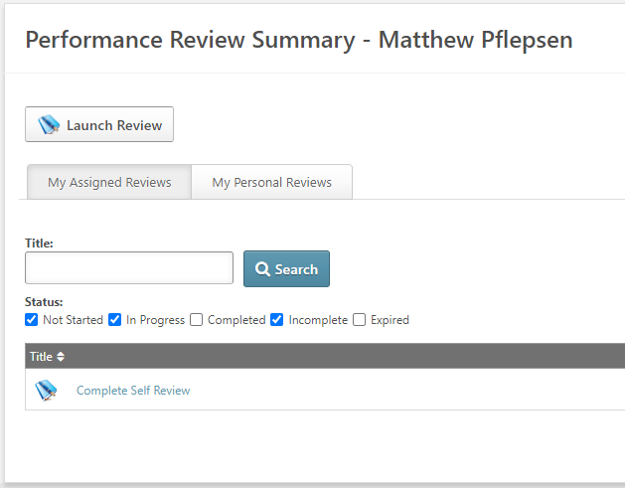 |  | User or Manager | 10 seconds
2a | Option 2.  Log in to Rogers University. | CLICK HERE |  | User or Manager | 10 seconds
2b | On the Welcome Page under ‘Your Tasks,’ click on the review you wish to save. You may need click on ‘Your Tasks’ to see the entire listing to find the desired review.  Note: Only tasks not started or still in progress may be found here. | 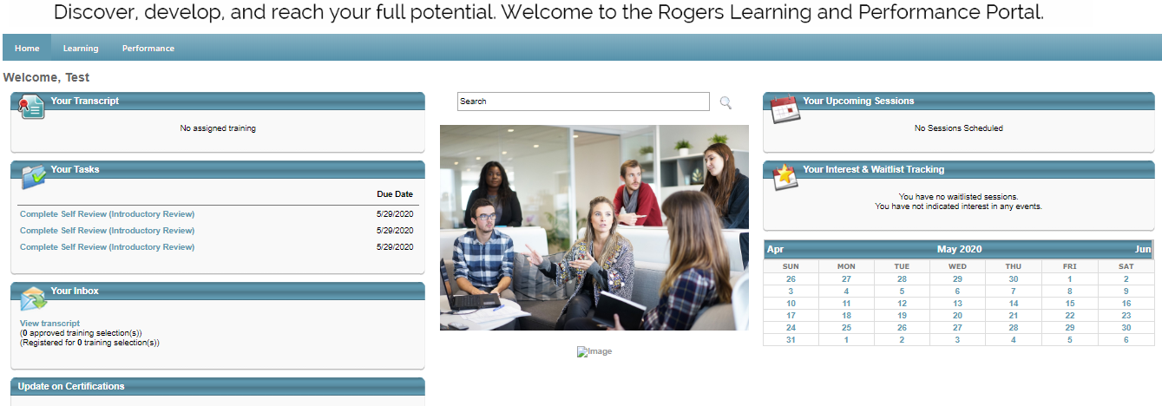  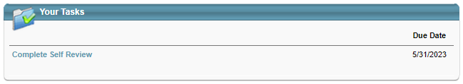 or 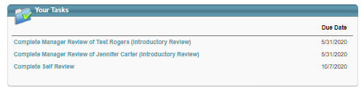 |  | User or Manager | 10 seconds
3 | Select ‘Options’ on the upper right of the template and choose ‘Attachments’ from the dropdown. | 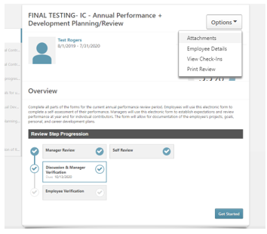 |  | User or Manager | 1-5 minutes
4 | A new window will open allowing for up to (3) three attachments to be added to the review.  You will need to search for the local copy of the file by selecting ’Choose File’ | 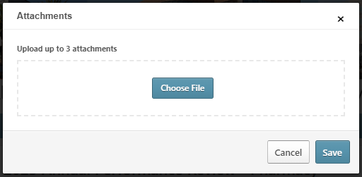 |  | User or Manager | 1-3 minutes

