 |  |  | Standard Work Sheet
Process: Print and Save a Review |  |  | Purpose: How to print and save a copy of a review.
Total Cycle Time: |  |  | Takt Time:
Work in Progress: n/a |  |  | Document Owner: Talent Development
When does this process occur: For Face to face meeting
Revision # |  |  | Date Updated: 6/1/2020
Step | Description: | Key Point / Image / Reason |  | Who | Cycle Time
1 | Option 1.  Navigate directly to your Performance Review Summary page by clicking the link provided.  You will need to toggle between reviews assigned to you, or your own review as necessary.  Select/deselect required status to find the desired review.  Click the desired review once identified. | Click here to navigate to your Performance Review Summary Page  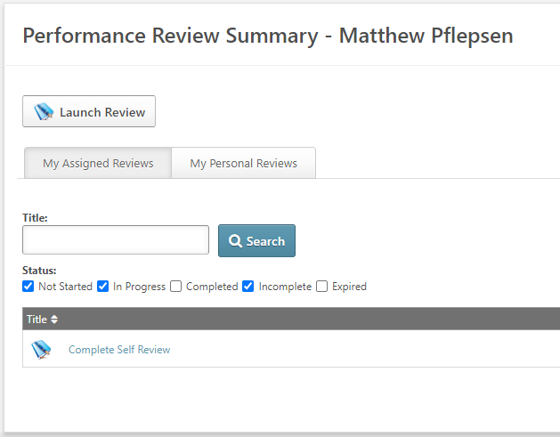 |  | User or Manager | 10 seconds
2a | Option 2.  Log in to Rogers University. | CLICK HERE |  | User or Manager | 10 seconds
2b | On the Welcome Page under ‘Your Tasks,’ click on the review you wish to save. You may need click on ‘Your Tasks’ to see the entire listing to find the desired review.  Note: Only tasks not started or still in progress may be found here. | 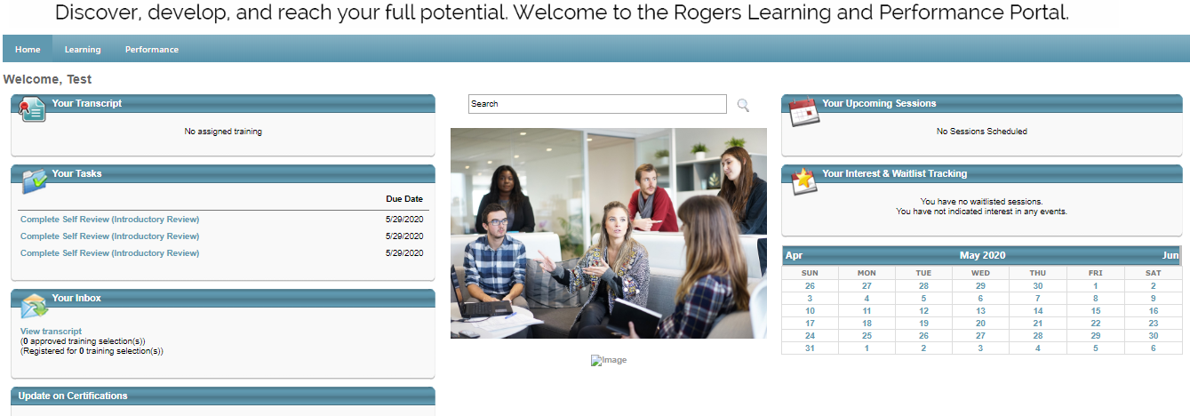  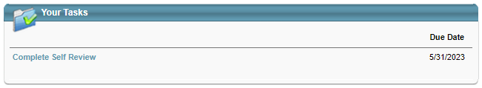 or 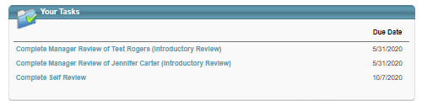 |  | User or Manager | 10 seconds
3 | Select ‘Options’ on the upper right of the template and select ‘Print Review’ from the dropdown. | 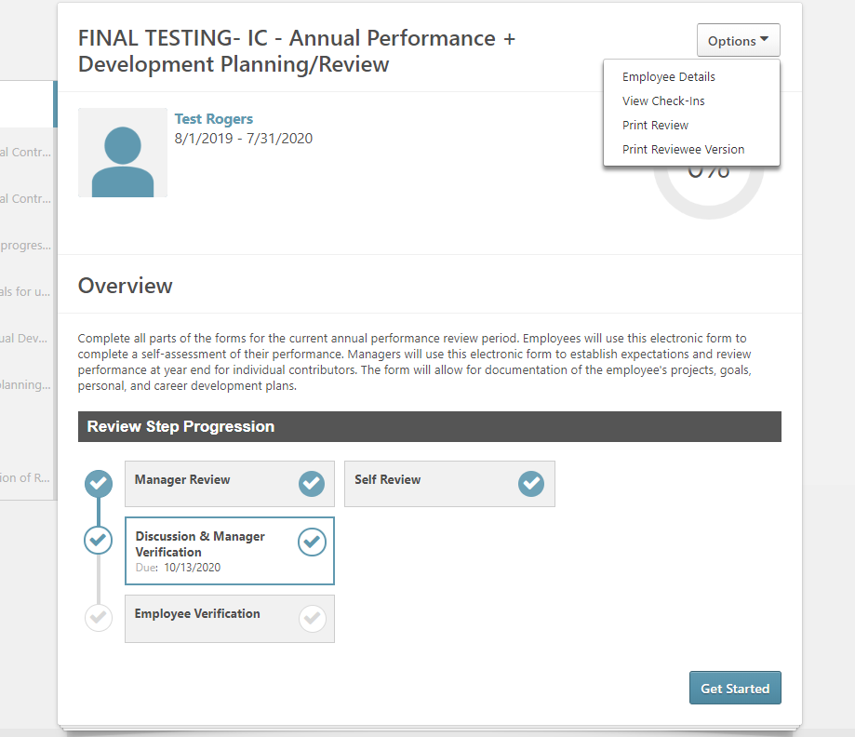 |  | User or Manager | 1-5 minutes
4 | The PDF that downloads either within the browser window or file folder may be printed or saved to a local drive as needed. |  |  | User or Manager | 1-3 minutes

