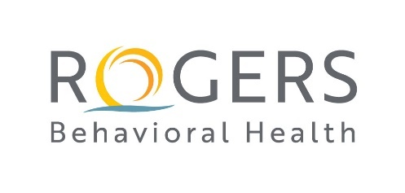
RBH MSOE PMHNP Scholarship Form DUE March 1, 2022

Name
Email
Primary Phone
Entry Year
Address

List all Universities/Colleges you have ever attended and Degrees Earned with dates.

Any programs / courses /credits in progress now?

Personal Statement - Please answer the following questions and attach as a WORD document:
- What are your professional goals for being an Advanced Practice Nurse?

- How will your work as a PMHNP benefit Rogers?

- NP programs are required to teach the care of clients across the lifespan. Who is your population of interest and how do you plan to help them?

Please email this form, your 2-page personal statement, and your signed scanned manager meeting confirmation letter to Dr. Martha Libster martha.libster@rogersbh.org.

Manager/Director Meeting Confirmation

I __________________________________________ have met with

___________________________________________ about her/his decision to pursue

higher education and the MSOE scholarship.

____________________________________________
Manager Name

___________________________________________
Date

___________________________________________
Contact Email / Phone

